CRYSTAL RADIO

EE 421 – Experiment 9 Lab Report

by

Aman Khatri, kaman

Experiment performed on 20th April 2012

Report submitted on 26th April 2012

EE 421 – Communication Systems

Department of Electrical and Computer Engineering

The University of Alabama at Birmingham

Lab Team:

Aman Khatri

Abstract

The project involves building a crystal radio and demonstrating its operation. The radio allows the reception and tuning of seven radio stations and requires no external power source to function.

**Table of Contents**

Abstract i

Introduction 3

Theory 3

Equipment List 5

PROCEDURE: CONSTRUCTION OF THE CRYSTAL RADIO 6

Conclusions 11

References 11

Introduction

In this experiment, a crystal radio is designed. A crystal radio is a simple radio which does not require any external power supply. It runs on the radio waves received via Antenna.

Theory

“At the turn of the 20th century, an American scientist, Greenleaf Whittier Pickard, found that a number of naturally occurring crystalline minerals could be used to detect radio signals. The detection occurs at the contact point between the crystal and the tip of a piece of wire. Radios employing this kind of detector became known as *crystal radios*. In the typical early radio-wave crystal detector, the crystal rock was fixed into a brass cup and the radio operator found the loudest signal by touching the wire, called a *cat’s whisker*, to various points on the surface of the crystal. In the early days of radio, people built and used simple and inexpensive crystal radio sets that worked without electrical power from wall sockets or batteries, and this technology was known as *wireless*. Even after vacuum-tube radios came into widespread use following World War I, crystal radios remained popular, especially among beginning amateur radio enthusiasts, boy scouts, and school kids, who continued to build crystal radios as their introduction to the field of communications.

During the Great Depression, a perfectly workable crystal radio detector could be constructed from a five-cent piece of galena crystal and the wire from a safety pin, and building and using homemade crystal sets brought endless hours of enjoyment to children of the Great Depression. After the detector was connected to iron bedsprings (which doubled as an antenna) and grounded to household cold-water pipes, a youngster needed only inexpensive headphones to bring in the world of radio—all the power needed to run the crystal set came from the ‘air’.” [1]

A crystal radio works without any external power supply except from the radio waves. In general, the antenna of the crystal radio picks up the radio waves and feds it to the inductor coil. A simple crystal radio consists of following parts:

1. An antenna to receive radio signals.
2. A circuit which consists of an inductor and a capacitor to tune into a specific radio station.
3. A diode, which demodulates the signal from the carrier wave. It does this by the process of rectification of the received wave. Although, there are no perfect diodes available, the desired rectification can be obtained by a germanium diode.
4. A high impedance earphone to converted audio signal which can be heard.

**The Coil, Antenna, Ground and Phones**

http://bizarrelabs.com/images/dot_clear.gif”The coils for the inductor is typically wound around a 1 1/2 to 2 1/2 inch (38 - 64 mm) diameter core, using 75 to 150 turns of 24 to 20 gauge wire. What is critical is that the individual loops of wire around the coil are wrapped touching the next one over, but that they do not ever overlap. It is also important that whatever attaches the coil to the base can not touch the coil's wire, especially if it is a metal tack or nail. A coat of shellac or varnish helps to keep the coil together. Let it dry thoroughly before using. If a wiper type switch is used, the varnish will need to be scraped away along its path.

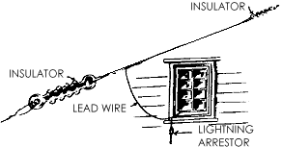http://bizarrelabs.com/images/dot_clear.gifIdeally, the antenna should be 100 feet ( 30 m) or so long, and strung as high as possible. Insulated or non-insulated wire can be used. Either way, the un-insulated ends should not touch anything that will ground them. It is best if they are tied off to ceramic or plastic insulators, which can in turn be tied off between two high points outdoors, such as a tree limb and your house. Never string an antenna anywhere where it has even the slightest chance of coming into contact with a power line, or in a place where you will need to go near a power line to hook it up. Always take the antenna down if a storm or lightning is predicted. It is safe practice to add a lightning arrestor to you lead wire. You can purchase in many radio and electronic hobby shops antenna kits which include the antenna, insulators, lead wire, and lightning arrestor.

http://bizarrelabs.com/images/dot_clear.gifThe ground wire can be attached to a metal cold water pipe, or to a metal rod stuck a couple of feet into the earth. Do not attach it to a line carrying gas or electricity.

The headphones (or earphone) need to be high the impedance type designed for crystal sets. They are still available through electronics suppliers and some hobby shops.” [2]

**The Capacitor**

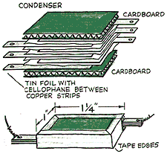“The capacitor, or condenser, though not essential for operation of these sets, does help to refine their use when it is added. More complicated sets have a variable capacitor. For the simplest sets, however, a fixed capacitor of around .002 mF or so is sufficient. A capacitor is also very simple to build. The Cub Scouts, being the great caretakers of crystal radio lore that they are, included this picture in the 1954 edition of the Wolf Cub Book. It lacked annotation of any kind other than what is here. The most important thing to know is that all of the tinfoil pieces need to be completely insulated from one another. They cannot touch each other in the least. The whole thing should be bundled tightly with cellophane tape. Also, aluminum foil is more common these days than is tin foil. It will work just as well.[2]”

After collecting all the parts for radio it is required to build a resonant circuit which resonates at the frequency of the station to which a person wants to tune into. The resonance is the property which involves continuous change of energy from one form to another. Also, its purpose is to reject stations which are undesired. This circuit is built using the inductor coil and the capacitor. However it is not possible to build a resonant circuit which does not involve loss of energy. This loss is measured in terms of Q. In general, Q is reciprocal of the loss, so it can be called the quality factor. This implies that high Q results in less loss in the process of energy conversion. The bell shape curve shows (Fig.1) below shows different quality factors. It also shows how the shape of the bell shape curve changes with Q. It can be concluded that for a radio station we require Q to be a certain value which is neither to high nor to low because, if Q is low the radio would receive many radio stations at same time, and if Q is high, the radio would be to perfect and not receive any signal. The typical value of Q depends on the band width of the radio stations.

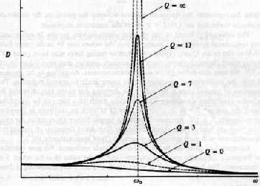

# Fig.1 Quality factor Curve

# Equipment List

* 1 Bread Crumbs box
* Antenna Insulators and wire.
* Ground wire that connects to the sink.
* Litz wire
* Variable capacitor- 21pf – 405pf.
* Germanium detector diode.
* High impedance earphone.
* Circuit board.
* Connector.
* Connecting wires.

**PROCEDURE**

First, a capacitor with a total capacitance of 420pf was bought and then the inductance required for the receiving the maximum frequency of 1700 KHz was calculated using the formula

Then, the 50ft litz wire of 240 (which is very close to 209) was used to build a coil by wounding it around the breadcrumbs can. The litz wire was chosen to build the coil because it reduces the skin effect and proximity effect losses in conductors used at frequencies up to 1MHz. It consists of many thin wire strands which are twisted together. After it the circuit shown in Fig.2 was built on the breadboard using 1N34 Diode and a high impedance earphone. The capacitor of 0.01 and the 82K resistor were borrowed from the Electronics lab.

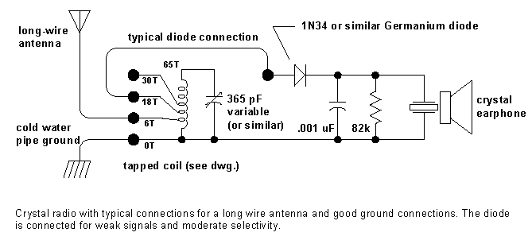

Fig.2 Circuit for Radio

The radio thus built (Fig. 10) was demoed on 24th of April 2012 and it received following AM radio stations and the corresponding coverage figures.

Table 1. AM stations received

|  |  |  |
| --- | --- | --- |
| **AM Radio Frequency** | **Radio Station** | **Radio Station Coverage** |
| 610 KHz | WAGG | Fig.3 |
| 690 KHz | WJOX | Fig.4 |
| 850 KHz | WXJC | Fig.5 |
| 960 KHz | WERC | Fig.6 |
| 1070 KHz | WAPI | Fig.7 |
| 1260 KHz | WYDE | Fig.8 |
| 1400 KHz | WJLD | Fig.9 |



Figure 3. Daytime coverage area for WAGG 610 AM

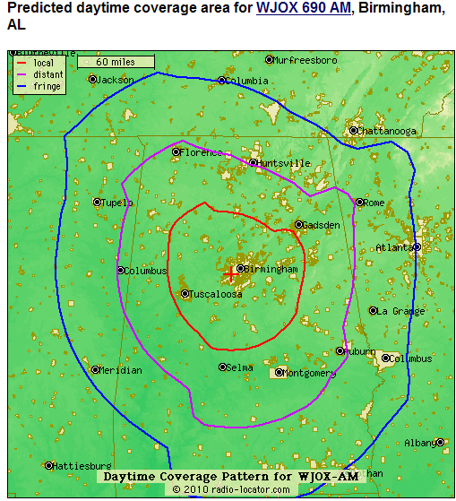

Figure 4. Daytime coverage for WJOX 690 AM

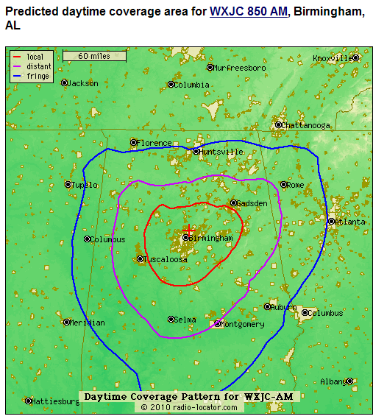

Figure 5. Daytime coverage for WXJC 850 AM

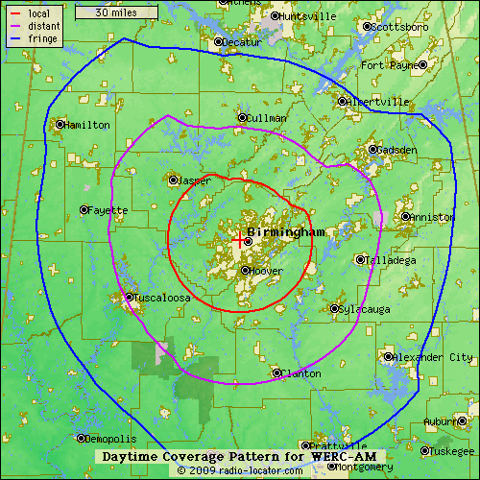

Figure 6. Daytime coverage for WATV 960 AM



Figure 7. Daytime coverage for WAPI 1070 AM



Figure 8. Daytime coverage for WYDE 1260 AM



Figure 9. Daytime coverage for WJLD 1400 AM

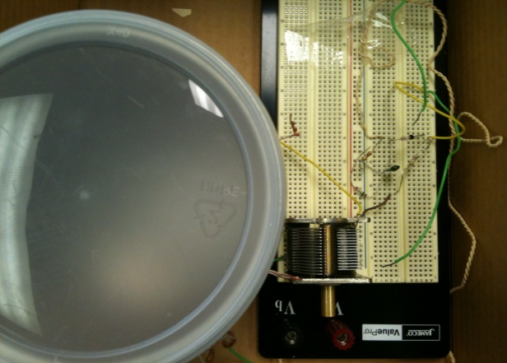

Fig.10a Top View of Radio

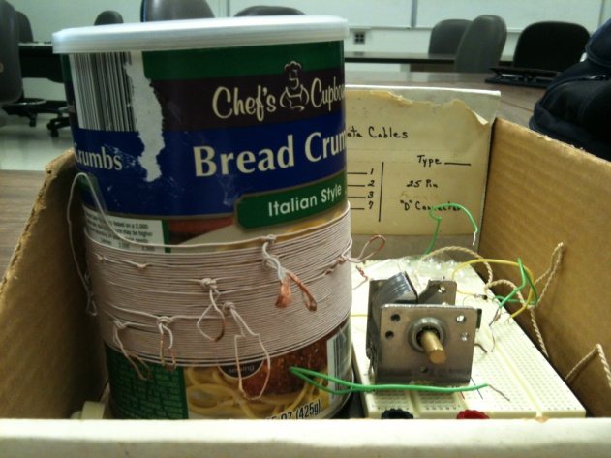

Fig.10b Top View of Radio

The estimated price for the components used in building the radio is given below

|  |  |
| --- | --- |
| **Equipment** | **Price** |
| Litz Wire | $12.00 |
| Variable Capacitor | $10.00 |
| Diode | $1.00 |
| Ear Piece | $3.00 |
| Total | $26.00 |

Conclusions

The radio was successfully built and it received more stations then the specification of the assignment. Interestingly, the radio was built under $30.

References

1. <http://www.arcsandsparks.com/aboutcrystalradios.html>
2. http://bizarrelabs.com/crystal.htm
3. http://en.wikipedia.org/wiki/Litz_wire
4. http://www.kennethkuhn.com/students/crystal_radios/